**Create KeySpace :**

CREATE KEYSPACE Student WITH REPLICATION = {'class':'SimpleStrategy','replication_factor':1};

**Describe the existing Keyspaces:**

DESCRIBE KEYSPACES;

**For More details on existing keyspaces:**

SELECT * FROM system.schema_keyspaces;

**use the keyspace “Students”:**

USE Student2;

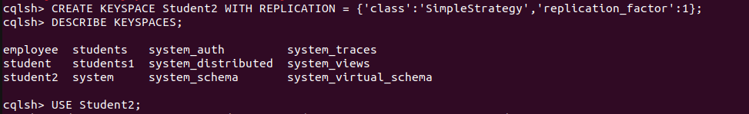

**To create table (column family) by name Student_Info:**

CREATE TABLE Students_Info (Roll_No int PRIMARY KEY, StudName text, DateOfJoining timestamp, last_exam_Percent double);



**Lookup the names of all tables in the current keyspaces**

DESCRIBE TABLES;



**Describe the table information**

DESCRIBE TABLE STUDENTS_INFO;

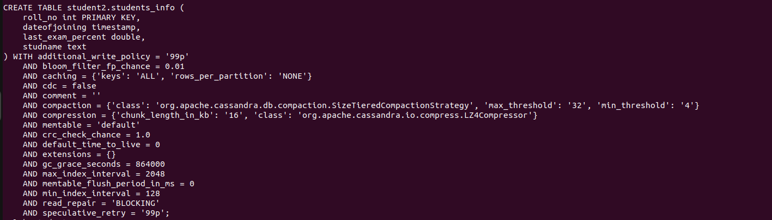

**CRUD**

**Insert :**

BEGIN BATCH

INSERT INTO Students_Info(Roll_No, StudName, DateOfJoining, last_exam_Percent)

VALUES (1,'Asha','2012-03-12',79.9)

INSERT INTO Students_Info(Roll_No, StudName, DateOfJoining, last_exam_Percent)

VALUES (2,'Krian','2012-03-12',89.9)

INSERT INTO Students_Info(Roll_No, StudName, DateOfJoining, last_exam_Percent)

VALUES (3,'Tarun','2012-03-12',78.9)

INSERT INTO Students_Info(Roll_No, StudName, DateOfJoining, last_exam_Percent)

VALUES (4,'Samrth','2012-03-12',90.9)

INSERT INTO Students_Info(Roll_No, StudName, DateOfJoining, last_exam_Percent)

VALUES (5,'Smitha','2012-03-12',67.9)

INSERT INTO Students_Info(Roll_No, StudName, DateOfJoining, last_exam_Percent)

VALUES (6,'Rohan','2012-03-12',56.9)

APPLY BATCH;

**View data from the table “Students_Info”**

SELECT * FROM Students_Info;

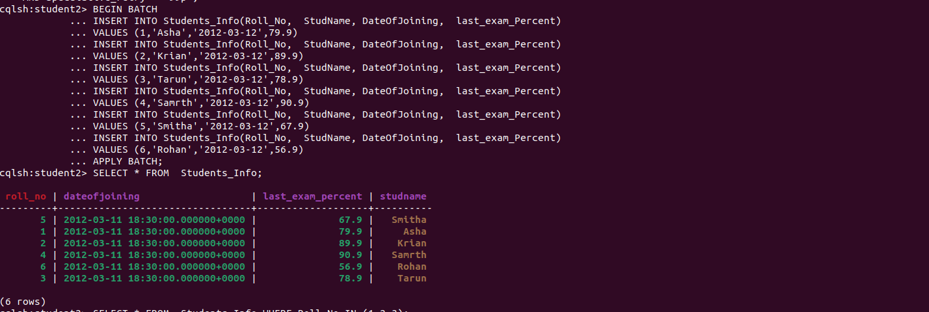

**View data from the table “Students_Info” where RoolNo column either has a value 1 or 2 or 3**

SELECT * FROM Students_Info WHERE Roll_No IN (1,2,3);

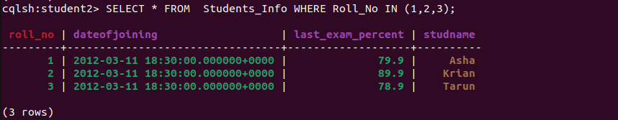

**To execute a non primary key - will throw an error**

select * from students_info where Studname= 'Asha';



**So create an INDEX on the Column as below:**

**To create an INDEX on StudName Column of the Students_Info column family**

CREATE INDEX ON Students_Info ( StudName);

**Now execute the query based on the INDEXED Column:**

select * from students_info where Studname= 'Asha';



**To specify the number of rows retured in the output**

select Roll_No, StudName from students_info LIMIT 2;



**Alias for Column:**

Select Roll_No as “USN” from Students_info;

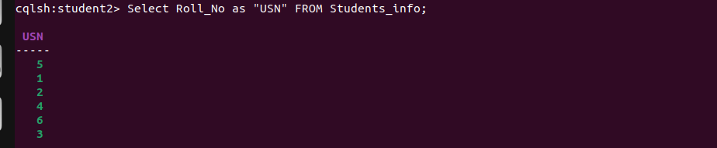

**UPDATE**

UPDATE students_info SET StudName='David Sheen' WHERE Roll_No=2;



Lets try to update the primary key

UPDATE students_info SET roll_no=6 WHERE roll_no=3;



DELETE

DELETE LastExamPercent FROM students_info WHERE Roll_No=2;



Delete a Row

DELETE FROM student_info WHERE RollNo=2;

